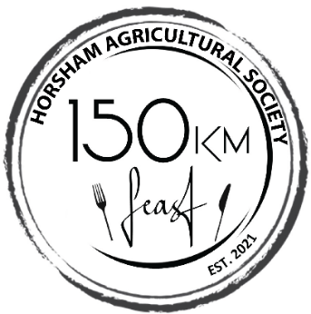

The Horsham Agricultural Society’s inaugural 150km Feast was held in the historical precinct of the Maydale Reserve nestled in the heart of Horsham on the banks of the Wimmera River in February. An outdoor dining room was built from approx 150 large square hay bales with 10-metre-high walls.

The 150km Feast showcased local food producers and wineries and engaged the services of over 50 small businesses within 150km of Horsham for 150 guests who paid $150 a ticket. Being the first large scale social event following lockdown, it was virtually sold out prior to tickets going on sale, so the society added a second date a week later, which sold out in 3 days to over 300 people in the final tally.

The impact of the short circuit lockdown pushed the event to run back-to-back, forcing volunteers including 4 chefs to almost work around the clock over the preceding 4 days, to prepare two 5 course meals. Volunteers included over 50 multi-cultural women, school students at risk and people of all abilities who were provided free training in hospitality.

Guests came from Brisbane, Sydney, Macarthur, Ballarat and Horsham. Almost $25,000 was raised to enable the 2021 agricultural show to proceed.

